Computer Science 220

Assignment 2

Due: See lms.cofc.edu (OAKS)
As stated in the course policies on the syllabus, the due date/time is firm. Do not send your assignment via email. Partial solutions may be given partial credit.

Learning objectives:
- Create a Python program on your own.
- Develop a simple Python program that asks for input, does arithmetic, and provides output.
- Practice definite loop
- Apply the Software Development Process.

Assignment:
Applying the software development process will make implementing your solution easier. Ask yourself, and write the answers to, questions 1-3 BEFORE implementing a solution in Python. Your answers should be part of the comments at the top of your program.

- What will the program do?
- What will be the inputs and outputs?
- What is a step-by-step list of what the program must do, aka an algorithm? (Remember this is in English!)
- Implement your code.
- Test your program.
- Maintain.

Programming problem:
The average of a set of numbers is often used in calculations. We have seen during lecture how to calculate the most basic of means. For this assignment, you are to write a Python a program designed to output the RMS (root-mean-square) Average and the Harmonic Mean. These represent two different methods for calculating a mean of a set of numbers.

The average of a set of numbers, as discussed during lecture, is given by the formula:

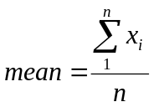

The rms average of a series of numbers is the square root of the arithmetic mean of the squares of the numbers and is used by electrical engineers. It is given by the formula:
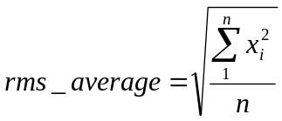

The harmonic mean is often used when ratios are involved. It is given by the formula:
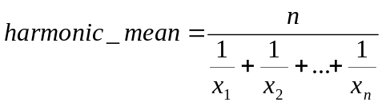

Your code should allow the user to specify the number of values to be entered. As a testing example, the values 10, 5, 2, and 5 have a rms average = 6.205 and a harmonic mean = 4.0.

Save your program as mean.py

File to be submitted:
mean.py

Submission instructions:
Log on to OAKS. Click on the link to the dropbox for our class. Upload your files into the folder for HW2. Be sure to press the submit button.

Policies:
The policies given on OAKS are in effect for this and all assignments.

